

Goklyn pvt. ltd.  
  
Zomato Data Analysis  
  
Project Documentation  
  
Submitted by: Team B (Data Analysis)  
  
Leader: Hitanshu Saini

Members:

Somya Khandelwal

Tanvi

Vishnu Shekhawat

Pulkit Jaiman

Hariom Singh

Submitted to: Mr. Ravindra Yadav

**Data Analysis Project – Documentation**

**Project Title:**

Zomato Data Analysis Using Python

**Objective:**

To analyze how restaurant pricing influences customer ratings and votes.

**Key Goals:**

1. Understand the effect of pricing on aggregate ratings
2. Determine how pricing affects vote count
3. Determine whether there’s a price “sweet spot” where customer engagement is highest.

**Tools & Technologies Used:**

* Python
* Numpy
* Pandas
* Seaborn
* Matplotlib
* Jupyter Notebook

**Step by Step Analysis:**

**1. Importing Required Libraries**

Code:

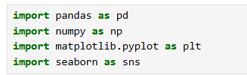

**2. Data Loading and Preview**

Code:

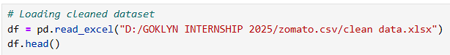

Output:

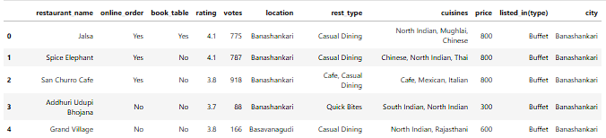

**3. Null Value Analysis**

Code:



Output:

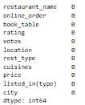

**Goal 1: Analyze the Impact of Pricing on Aggregate Ratings**

**Objective:**

Determine whether higher prices lead to better ratings and if there's any consistency in satisfaction across different pricing levels.

**1. Group Price And Compute Average Rating**

Code:



**2. Sort By Price**

Code:



**3. Visual**

Code:



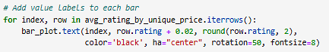

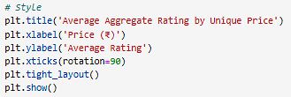

Output:

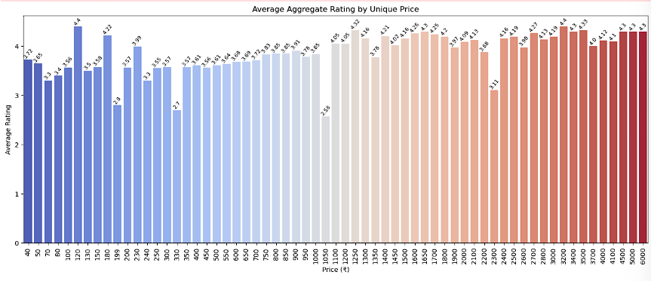

**Observation:**

There is moderate fluctuation in ratings across price brackets. Some mid-range price levels maintain consistently high ratings, suggesting a sweet spot where customers feel value for money.

**Goal 2: Analyze the Impact of Pricing on Votes**

**Objective:**

To examine if higher prices correlate with increased customer votes, indicating engagement or popularity.

**1. Group Price And Compute Total Votes**

Code:



**2. Sort By Price**

Code:



**3. Visual**

Code:



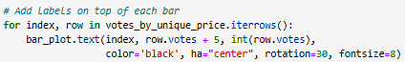

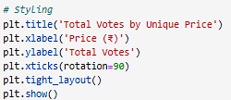

Output:

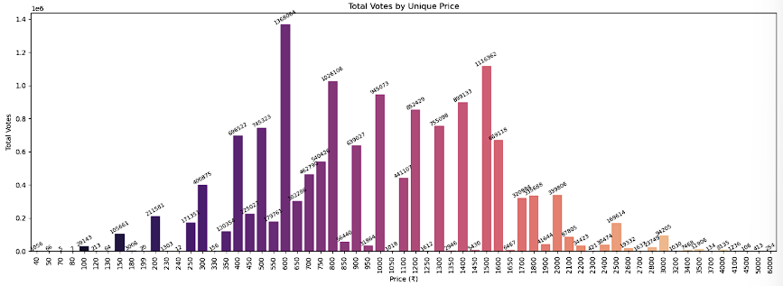

**Observation:**

Higher-priced restaurants tend to receive more votes, potentially due to brand reputation or better service. However, the presence of engagement at lower price points suggests strong performance by budget-friendly options too.

**Goal 3: Identify the Sweet Spot**

**Objective:**

To discover the optimal price range ("sweet spot") where restaurants achieve both high customer ratings and significant engagement (votes). This helps in pinpointing the pricing tier that maximizes both customer satisfaction and popularity, aiding strategic pricing decisions for restaurants aiming to enhance visibility and perceived value.

**1. Count the number of Restaurant in each Price Group**

Code:





Output:



**2. Count the Total votes in each Price group**

Code:





Output:



**Observation:**

* The **most common price point** by number of restaurants is **₹400**, indicating this is a popular tier among restaurant owners, likely due to perceived affordability and operational feasibility.
* However, the **price point with the highest customer votes** is **₹600**, which suggests that customers are more engaged and responsive at this slightly higher price tier.